**No. 1 Poem**

**Guruji is still there**

Guruji is still there

Guruji is still there, forever there,

At that corner, in Pune,

Ramamani center,

Our sacred yog temple.

First met Him there,

It becomes the forever!

He was there, we were there,

At that moment, we are together.

Last year he left there,

For he left for higher,

Though he is up there,

Guruji will be at the corner,

Watching us,

For we can feel Guruji when we yog,

Keep in mind that corner,

We all miss you, forever and ever.

By Ms. Liang Hong (梁宏)， Iyengar Yoga Practioner

**No. 2 Poem**

**The beauty of life**

Divine rain…

On the departure of the great divine being..…

Clouds get numb with gratitude..

And expressing their devotion towards him..

The radiance of summer has gone…

Cool breeze of winter is still away..

Just left the withered autumn alone…

“ My end will be your beginning.”

Echoing in my ears..

The sacred words became the holy mantra…

Continuous recitation in my conscience..

On the west land, Pune …

Having long silence and in deep Samadhi..

Guru gave the great talk on yoga dharma..

“ I have already shown the path to you , now you have to practice by your own.”

Have made the Giant ship for you …

Now you have to sail alone…

The enlightened soul departs with ease..

As you completed with perfection, His given tasks..

The whole universe at deep silence and peace..

The divine light merge into the divinity..

The day we heard Guru left us…

Eyes get numb but tears dried…

Deep within the heart, comfort and solace..

The innermost core of our being in peace…

Yet there are strong waves and tides within…

Speechless and void of words…

The true nature of the material world..

What born surely dies..

There is flourishing spring, so there is autumn’s dry…

Everything between existence and non-existence..

Cycle of life and death…

The wheel of karma..

Moving endlessly …

For the material world, you have gone to that shore…

People think they can’t see u anymore…

But for the true seekers of yoga…

You gifted the divine insight…

Everywhere we see you..

In our practice and in our daily life…

At the beginning of the day…

When we sit down and pray…

Begin with the invocation…

And find our beloved guru everywhere…

Recollecting our Guru’s words …

So blessed we are…

That you live in our heart…

Through your life time tapa and sadhana, you overcome all the hurdles by yourself…

You paved the way to the ultimate goal….

Now as the path is smooth enough, we have no fear to walk…

just with faith and devotion follow the path towards the destination..

You experimented the yoga science on yourself first..

put your heart and soul to the reach the highest..

Extracted the nectar of life through it..

And illuminated this ancient science of yoga again..

Shined the whole world with the ancient wisdom..

And removed the darkness of self through yoga…

And now we following your guidance and carrying the torch of yoga…

With sincerity, humbleness, firm determination and intelligence..

By Sasa Shang (商红英)，Gloria Goldberg’s Year three student of Introductory II in Iyengar Yoga Institute of China

**No. 3 Poem**

**Beloved Guruji**

Oh gigantic mountain, we do admire your highness..

Oh deep ocean, we do praise your vastness..

Oh beautiful flowers, we do adore your luminous colors..

Oh huge tree , we do regard your courage of transforming from a tiny seed to a great shelter..

but how do we express the greatness of our beloved guru..

Who devoted his whole life to expound the great ancient wisdom of yoga..

who surrendered his soul to extract the real essence of the yogic art and science...

Having a bunch of lily flowers , in our tiny hands

a divine fragrance into the atmosphere..

came today to worship at your holy feet..

its you who brought us the real meaning of this mundane life..

taught us how to live this life in depth...

made us absorbed into the true nature of the spirit of life ...

embraced us and kept us away from the darkness...

with the firm determination and  deep passion in our heart..

today came to pay homage to our revered guru..

its you who nurtured in us the seed of acceptance..

and grant us the gift of persistence...

just a glance of your giant persona ..

took the fear away from our heart..

and filled it with deep love and affection...

you bestow us with deep insight..

and took away the ignorance of our mind..

guiding us towards the spiritual light..

on the horizon , appears a beautiful rainbow just now..

it seems a bridge between human and divine..

showing the direction towards the eternal path..

a great service of my guru towards humanity and mankind...

By all of Gloria Goldberg’s year three students of Introductory II in Iyengar Yoga Institute of China

**No. 4 Story with Guruji**

**Remembering Our Dear Guruji**

Guruji in China was big, highly respected and also a little mysterious. We somehow knew who he was, and at the same time, we didn’t really know who he was. The reason was very simple, the system was and still is relatively new so not many people had the chance of really being with him that much.

Of course I’m not saying that I know much, I was just a lucky girl, a very lucky one. I was fortunate enough to become the translator for the second group of Chinese students studying in Pune in September 2013. So he was right there in the corner practicing every morning during that month, he was supposed to give us a Q&A section in one Sunday morning, instead he gave us two plus a 2-hour morning class! So I was kneeling down at his feet, trying my very best to translate his every word. It was such an amazing and no doubt stressful experience.

I was nervous the day before, I should have been so days ago, but was busy translating other classes, so simply had no time. But big events always come faster than our expectations. So before I knew Guruji was there started talking, no time to be nervous, I had to begin. “There are responsibilities on you being the first group from China, of course it’s the second group but the first group may also be here. You must carry the subject as Buddha carried the subject of Buddhism to China.” When Guruji said this, I couldn’t help but letting the tears come out of my eyes. So that was the start…

In our group there was this one lady whose lower back was injured in an accident two years back. So she was constantly in lots of pain. She wanted some solid answer from Guruji. Guruji first asked her to do the pose which was bothering her. It was Salabasana, within 2 seconds he said: that’s not my method. He also asked whether she read his book “Light on Yoga” or not. Sadly she didn’t really read the book. In the book, there are clear instructions on how to do this to reduce back pain. To be honest, at that time, I didn’t quite understand why reading could be so important. It was way later after lots of other translation and study; I came to appreciate the idea of keeping a method pure and the value of reading THE books. Then Guruji put her into another pose, the Doctor and Raya were there helping her. We were all so amazed by Guruji’s unique insights, THE top-level skills and flash like thinking. Some of us were busy taking notes while admiring… But the girl didn’t seem to get it, still so confused. Everybody else was happy enough for the answer. So we were kind of ready for the next question. We knew that the clock was ticking…but Guruji insisted to give her the answer she’s looking for. So she was put into another pose. The pain was less than the first one. And we were again amazed by Guruji’s everything plus patience.

So finally we were moving on. 40 minutes later, Guruji was talking about himself having no favorites in life. He came back to the girl again! So this time she was put into Halasana with the bench. Because she’s in pain so she’s confused. He was showing us a confused mind. Then she was in Karnapidasana, the pain was less, much better. “That is science!” Guruji said. “I know there’s stiffness, so I move the inner muscles like butter. See her eyes, what happened? I saw the signs, the signs give the idea of how should I put her into the pose. All signs mean there’s something wrong in us, so we adjust according to the signs. And that is science.”

There were two more poses for her, she’s getting better and better by moments. Finally she could not hold back her tears, she kneeled down by Guruji’s feet, saying that she‘s never been this comfortable since the accident. Guruiji said: “That is compassion.” It was an amazing conclusion for the whole section. We didn’t know what’s really going on there until that moment. We all talk about compassion, without tremendous patience and outstanding skills, with what we can be compassionate?

People tried many different ways to describe Guruji even define him. We called him an artist, a scientist in yoga, a lion and a lamb, a man of action and perfection, a teacher, a master, a guru. He was all these and more. As a proud beginning student of his system, from my limited experience and reading I believe that his everything came from his practice, 80 years of non-stop practice. In his book <Iyengar-his life and work>, we came to know how those difficult years were like. And life was extremely hard on him for years and years. Yet his will alone held on despite of everything. “I made up my mind,” he said in the book, “that I would continue in my practice but would not give any publicity nor beg anyone for tuition or recommendation. My conviction grew stronger that I should continue in my yogic practice and live the same life as long as God willed it.” And that was exactly how he lived his life. He said this in the year 1941 and he was 23 years old at that time. I read those words many times and I see this great gumption in him. It reminds me of a Bodhisattva’s poem in the <Infinite life sutra> I read everyday. After making great vows he said that: “My body could be blocked by all kinds of difficulties, may such wills never fade”. That’s our dear Guruji.

Guruji built up this great model for us with his teaching, his practice and his life. Just as he said before leaving this world: “I have shown you everything, now it’s time for you to practice.”

So let’s do what he told us to do.

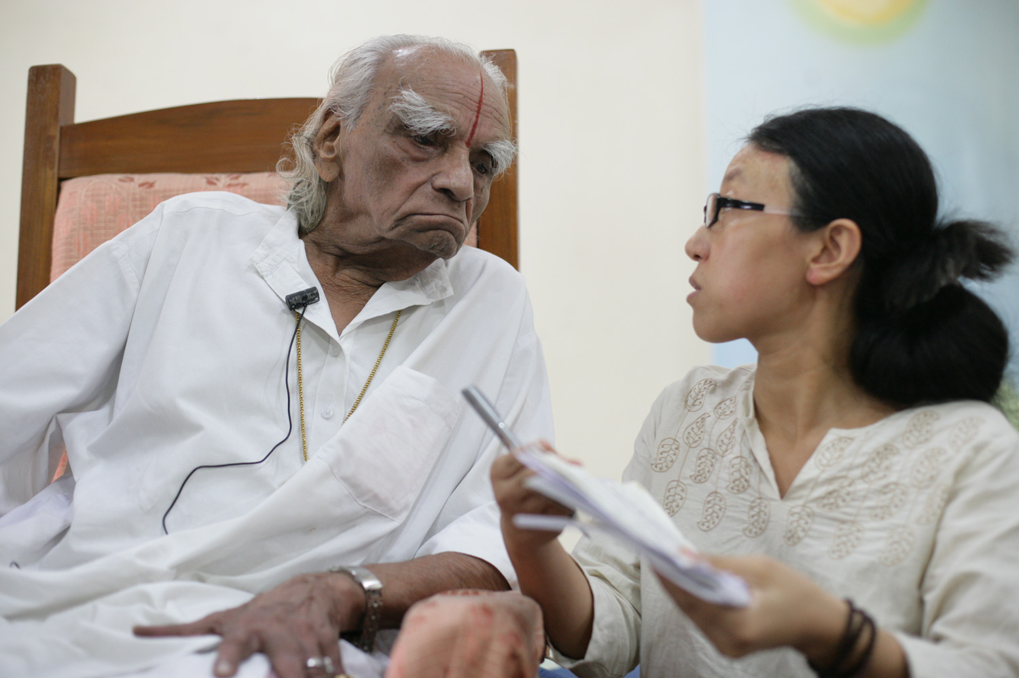By Wang chunming (王春明)，Iyengar Yoga Practioner and Translator

**No. 5 Story with Guruji**

**Guruji’s Return**

The first time and the only time I met Guruji was his visit to China in 2011 for the 1st China-India Yoga Summit.

B.K.S. Iyengar was nobody to me at that time, though I had been practicing yoga for 6 years and had just finish a 40-day course for yoga teacher. I was a so-called certified senior yoga teacher and yoga therapist. This was more than normal in China at that time.

After this course, I heard that an Indian yoga master would be coming to my city-Guangzhou to teach for 3 days. I guessed this Indian yoga master shall be real master. I should say there were so many yoga masters or king or queen in China at that time. I have no clear concept what the difference between Chinese master and Indian Master, not to mention this Indian master.

Still, I wanted to see this master. Then I applied to work as a volunteer for the 1st China-India Yoga Summit and luckily I got this chance. I didn’t buy the pass because I doubted that it may not be worthwhile.

As a volunteer, I found some opportunity to listen to this master’s class. Except feeling his teaching is different from what I learnt and he was really strict, I had no more special feeling on this man or his subject.

The turning point was on the 2nd day – June 18th, 2011. It is afternoon section and Birjoo was helping us review Guruji’s teaching in the morning. Suddenly Guruji show up in the venue among all the practitioners, not on the stage. He should be resting in the hotel for that afternoon. The camera shot him and he said that he was resting in the hotel and he wanted to see how the students practice. So he came.

The tears came out at that second. I didn’t see how he practices, neither did I realize how valuable his teaching is, but what I saw and was touched is his love to his new Chinese students. He attracted me not as how well he practiced and taught as a yoga master, but as a normal old man’s love and responsibility to his children. This is the moment I had with Guruji, forever in my memory – his return.

Of course, later on I practice Iyengar yoga up till now and help spreading this subject in China. I got to know how great this man is, but still, the most impressive experience is Guruji’s return.

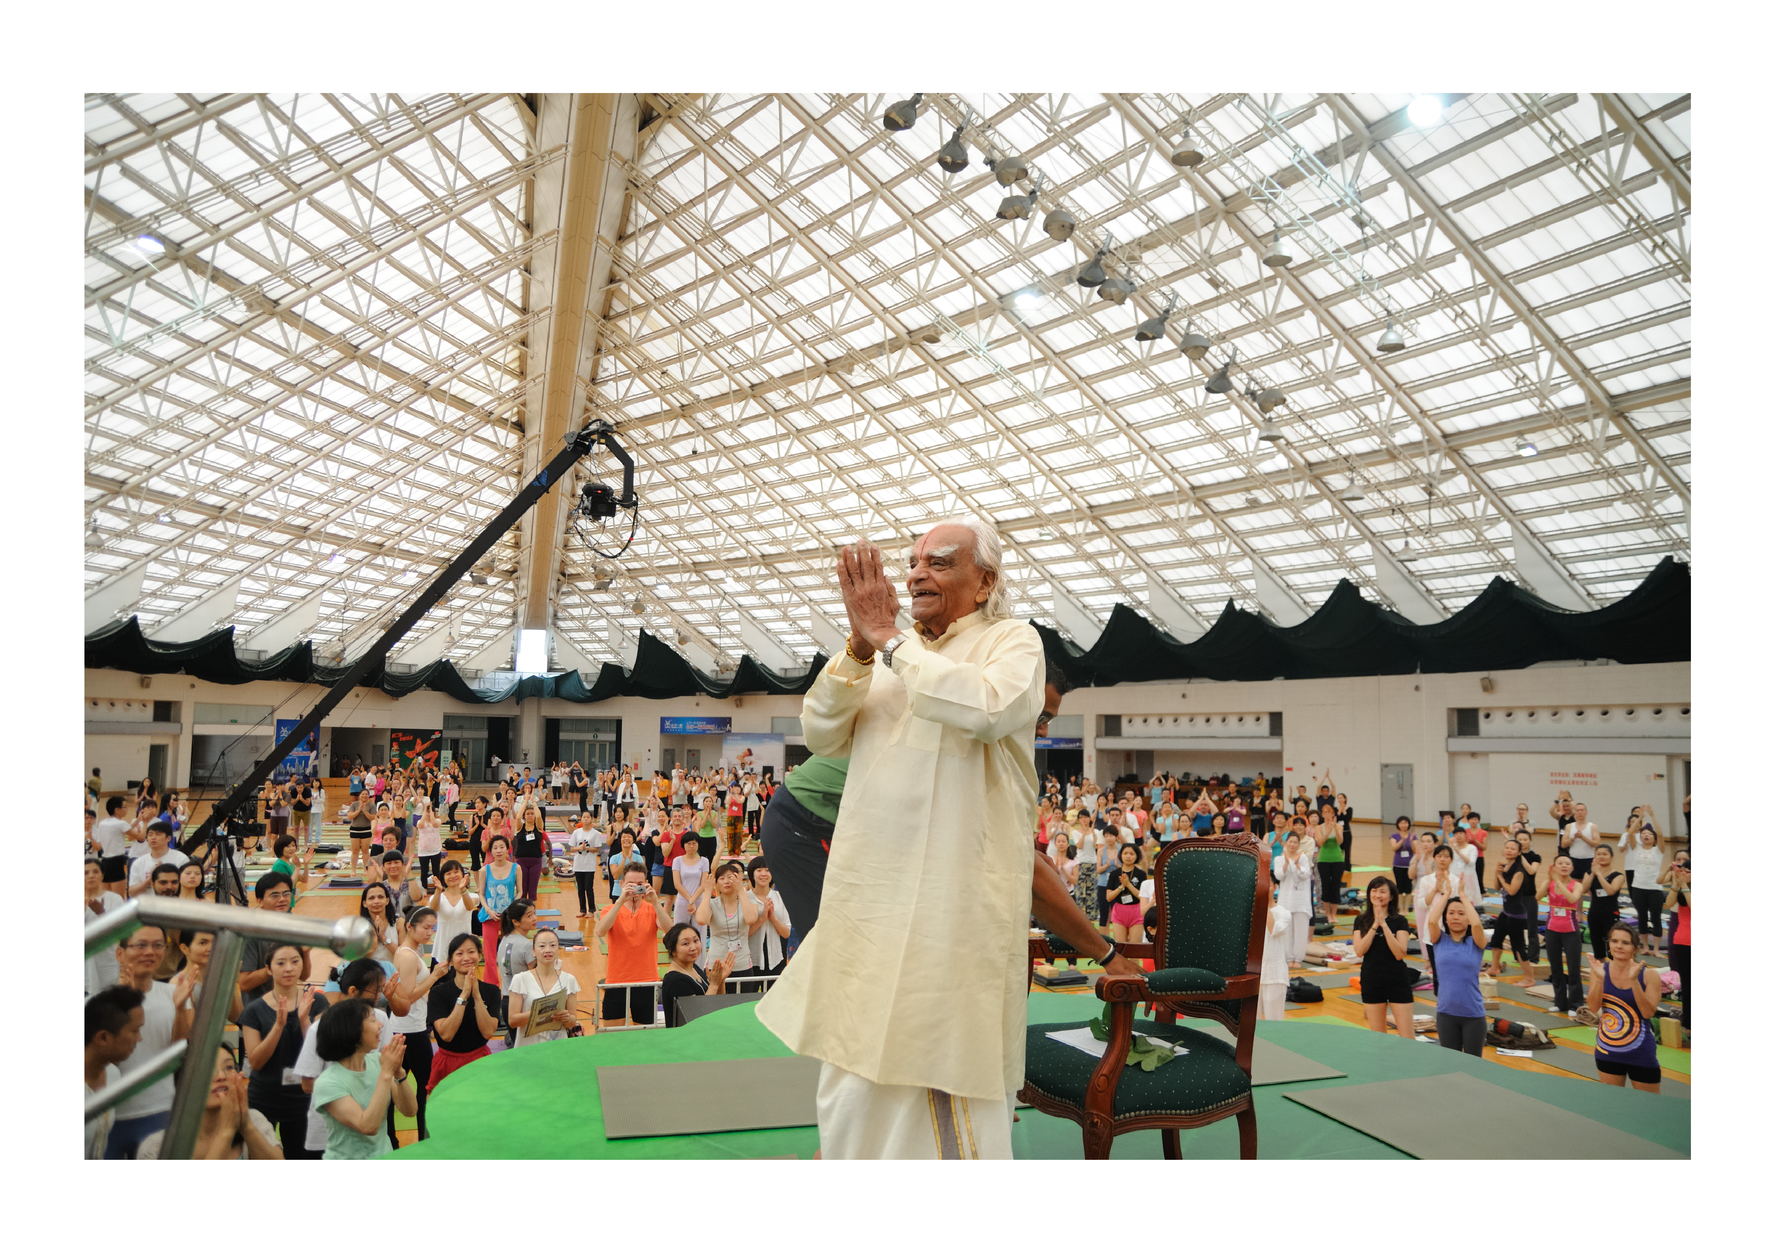By Evelyn Lee (李韵玲)，Gloria Goldberg’s Year one student of Introductory II in Iyengar Yoga Institute of China

